

**VELAMMAL INSTITUTE OF TECHNOLOGY**



### A PROJECT REPORT ON

### Autonomous Vehicles and Robotics

***Submitted by***

|  |  |
| --- | --- |
| **BHARATH VELAN S** | **113323106010** |
| **BALAJI R** | **113323106008** |
| **ABISHEK L** | **113323106001** |
| **ARJUN RATHINAM R** | **113323106005** |
| **BOOBALAN A** | **113323106011** |

***in partial fulfillment for the award of the degree of***

**BACHELOR OF ENGINEERING**

***IN***

**ELECTRONICS AND COMMUNICATION**

**VELAMMAL INSTITUTE OF TECHNOLOGY,THIRUVALLUR**

**ANNA UNIVERSITY : CHENNAI 600 025. APR / MAY 2025**

**ANNA UNIVERSITY: CHENNAI 600 025**

**BONAFIDE CERTIFICATE**

Certified that this project report **“AUTONOMOUS VEHICLES AND ROBOTICS”** is the Bonafide work of Bharath Velan S(113323106010), Balaji R(113323106008),Abishek L(113323106001), Arjun Rathinam R(113323106005), Boobalan A(113323106011). who carried out the project work under my supervision.

**SIGNATURE SIGNATURE**

Dr. B.SRIDEVI , M.E., Ph.D. Ms. R. HEMALATHA, M.E

**HEAD OF THE DEPARTMENT, SUPERVISOR,**

Department of Electronics and Department of Electronics and Communication, Communication,

Velammal Institute of Technology, Velammal Institute of Technology, Chennai – 601 204. Chennai – 601 204.

Submitted for the university examination held on………………… at Velammal

Institute of Technology, Chennai.

**INTERNAL EXAMINER EXTERNAL EXAMINER**

### ACKNOWLEDGEMENT

Support on demand, encouragement at the needed moment and guidance in the right direction are indispensable for the success of any project. We have received these in excess from all corners from various people, we are glad to submit our gratitude to them.

We Thank Shri. **M.V. Muthuramalingam**, Chairman and our sincere thanks to Chief Executive Officer, Shri. **M.V.M.Velmurugan** and Director,Shri. **M.V.M. Sasikumar** for their kind support to take up this project.

The esteem head of our institution **Dr.N.Balaji M.E.,Ph.D** has been a source of motivation to all the staffs and students of the college. We are thankful to him.

Our sincere thanks to **Dr. B.Sridevi M.E.,Ph.D** the head of the Artificial Intelligence & Data Science Department for her support and motivation throughout our project.

We Extend our sincere thanks To **Mr.K.Kaliagurumoorthi M.E.,(Ph.D).,** the Naan Mudhalavan Coordinator for his enthusiastic and innovative guidance during the entire period of our project.

We extend our sincere thanks to **Ms.R.Hemalatha M.E** Project Supervisor for her enthusiastic and innovative guidance during the entire period of our project.

We would also like to take this opportunity to thank all the staff members of the department Electronics and Communication Engineering.

## ABSTRACT

Autonomous vehicles and robotics are transforming industries and revolutionizing the way we live and work. These systems leverage advanced technologies like artificial intelligence, machine learning, and sensor fusion to enable machines to perceive their environment, make decisions, and take actions autonomously. Autonomous vehicles, for instance, use a combination of cameras, lidar, radar, and GPS to navigate roads, avoid obstacles, and ensure safe transportation. Robotics, on the other hand, is being applied in various sectors, including manufacturing, healthcare, and logistics, to automate tasks, enhance efficiency, and reduce costs. The development of autonomous systems requires sophisticated algorithms, robust hardware and software architectures, and significant testing and validation. As these technologies continue to evolve, we can expect to see significant improvements in areas like safety, productivity, and quality of life. With the potential to transform industries and revolutionize the way we live and work, autonomous vehicles and robotics are exciting and rapidly evolving fields that hold much promise for the future.

|  |  |  |
| --- | --- | --- |
| **TABLE OF CONTENTS** | | |
| **S.NO** | **TITLE** | **PAGE NO.** |
| 1 | PHASE - 1: PROBLEM DEFINITION & DESIGN THINKING | 01 |
| 2 | PHASE - 2: INNOVATION & PROBLEM SOLVING | 03 |
| 3 | PHASE - 3: IMPLEMENTATION OF PROJECT | 05 |
| 4 | PHASE - 4: PERFORMANCE OF THE PROJECT | 08 |
| 5 | PHASE - 5: PROJECT DEMONSTRATION AND DOCUMENTATION | 15 |
| 6 | CONCLUSION | 21 |

**PHASE - 1 PROBLEM DEFINITION &**

**DESIGN THINKING**

**Autonomous vehicles And robotics**

In the rapidly evolving landscape of artificial intelligence and automation, autonomous vehicles and robotics stand at the forefront of innovation. These technologies aim to transform daily life by improving safety, efficiency, and accessibility-goals that closely mirror the intentions behind AI-powered healthcare assistants.

**Problem Definition**

Modern society faces increasing challenges in transportation and labor efficiency. Traffic congestion, human error in driving, and labor shortages in critical sectors such as logistics and manufacturing create a need for intelligent, reliable alternatives. Autonomous vehicles (AVs) and robots can address these issues by offering consistent performance without fatigue or distraction.

Autonomous vehicles and robotics address modern challenges by enhancing sustainability, safety, and accessibility while improving precision and global connectivity. These systems optimize operations, reduce risks, and streamline processes across various sectors.

**End-users**

* Commuters and passengers: Individuals who can benefit from improved road safety and mobility.
* Logistics and transportation companies: Businesses that can enhance efficiency and reduce costs.
* Manufacturing and industrial companies: Industries that can automate tasks and improve productivity.
* Healthcare and medical institutions: Organizations that can use robots for patient care, surgery, and rehabilitation.
* Individuals with disabilities or mobility issues: People who can benefit from increased independence and accessibility.
* Public transportation agencies: Municipalities and organizations that can use autonomous vehicles for public transportation.
* Service industry: Companies that can use robots for customer service, hospitality, and education.

**Objective**

* To design autonomous vehicles that can safely navigate urban environments.
* To create robotic systems that assist in maintaining and improving transportation infrastructure.
* To develop an ecosystem where autonomous vehicles and robotics communicate seamlessly with one another.
* To ensure the system is scalable and can be adopted globally, accommodating diverse transportation needs.

**Design Thinking Approach:**

**Empathize**

The main challenge lies in public trust and safety concerns about autonomous vehicles and robotics. Some people fear that autonomous technology could lead to accidents or job displacement, while others are concerned about how these systems will be integrated into the current traffic infrastructure. The goal is to design a system that mitigates these concerns by ensuring safety, reliability, and a seamless transition to autonomous transport.

**Key User Concerns**

* Reliability of autonomous vehicles in complex, unpredictable environments.
* Public trust in the safety of robotic systems.
* Job displacement due to automation.
* The potential for technical malfunctions and cybersecurity risks.

**Define**

The solution should focus on creating a robust framework for autonomous vehicles and robotics that ensures high levels of safety, user trust, and efficient integration into existing transportation systems. This system should include communication protocols between vehicles, robots, and traffic management systems, as well as mechanisms for addressing emergencies and malfunctions.

**Key Features Required**

* Autonomous driving algorithms capable of handling diverse road conditions.
* Communication system between autonomous vehicles and traffic management systems.
* Real-time monitoring of robotic systems for maintenance and safety.
* Data security measures to protect against hacking and system failures.

**Ideate**

**Potential solutions include:**

* Autonomous vehicles equipped with real-time data sharing and communication with traffic management systems.
* Robotics for infrastructure repair, such as road inspection robots that work alongside autonomous vehicles to enhance safety.
* A cloud-based platform to monitor all autonomous vehicles and robotics in real-time, providing necessary updates and alerts.
* Integration of AI systems capable of improving vehicle navigation based on dynamic environmental data.

**Brainstorming Results**

* A fleet of autonomous cars that communicate with each other to optimize traffic flow and avoid collisions.
* Robotics designed for automated road repairs, such as robotic street sweepers or pothole patchers.
* An app or dashboard for governments and citizens to monitor the status of autonomous vehicles and robots in their areas.

**Prototype**

Develop a prototype autonomous vehicle that uses machine learning for dynamic navigation. The vehicle will be equipped with sensors to detect nearby vehicles, pedestrians, and infrastructure. A robot could also be prototyped for infrastructure monitoring, providing real-time data back to a central system.

**Key Components of Prototype**

* Sensors and cameras to detect and avoid obstacles.
* AI-based decision-making system for navigation.
* Communication system to connect vehicles and robots with a central traffic management system.
* A fail-safe mechanism to ensure safety during system malfunctions.

**Test**

The prototype will be tested in a controlled environment where autonomous vehicles and robots navigate urban streets and interact with other traffic systems. Feedback will be collected from participants, including commuters, traffic management officials, and robotic engineers.

**Testing Goals**

* Evaluate how well autonomous vehicles can navigate complex urban environments.
* Measure the reliability of robotic systems in maintaining infrastructure.
* Gather feedback on user trust and perceptions of safety.
* Assess the effectiveness of the communication systems between autonomous vehicles and traffic infrastructure.

**Conclusion**

Autonomous vehicles and robotics represent a transformative leap in the way machines interact with and navigate the physical world. These technologies, powered by advancements in artificial intelligence, machine learning, sensor networks, and real-time data processing, are rapidly redefining industries by improving efficiency, precision, safety, and scalability.

**PHASE - 2 INNOVATION & PROBLLEM**

**SOLVING**

# Autonomous vehicles and robotics

**Innovation in Problem Solving**

The goal of this phase is to explore and implement innovative solutions addressing key challenges in the fields of autonomous transportation and robotics. This includes safety, navigation, human-robot interaction, and system integration using cutting-edge technologies like AI, computer vision, and edge computing.

**Core Problems to Solve**

* Time Decision Making: Autonomous systems must make split-second Real decisions in unpredictable environments.
* Obstacle Detection and Avoidance: Robots and vehicles need to reliably detect and navigate around dynamic and static obstacles.
* Human Interaction and Trust: Gaining user confidence in robotic and autonomous systems remains a significant barrier.
* Energy Efficiency and Sustainability: Robotic systems should be designed for minimal energy consumption without compromising performance.

**Innovative Solutions Proposed**

**1.AI-Driven Perception and Navigation System**

Solution Overview: Integrate AI and deep learning models with sensor fusion (LiDAR, camera, radar) to allow autonomous systems to understand and navigate their environment.

Innovation: The system continuously learns from diverse driving scenarios and environmental conditions to adapt over time.

Technical Aspects:

* Deep learning for object recognition.
* Real-time sensor fusion.
* Path planning and collision avoidance algorithms.

**2.Human-Robot Interaction Framework**

Solution Overview: Develop a multimodal interaction system using voice, gesture, and touchscreen inputs for intuitive control of robots and vehicles.

Innovation: Emotion recognition and adaptive response mechanisms to improve trust and usability.

Technical Aspects:

* NLP and gesture recognition.
* Context-aware behavior modeling.
* Personalized user profiles.

**3.Energy Optimization Using Edge AI**

Solution Overview: Use edge computing to reduce latency and energy consumption during data processing.

Innovation: Implement an adaptive workload distribution system between cloud and edge devices.

Technical Aspects:

* On-device AI inference.
* Power-aware scheduling.
* Battery optimization algorithms.

**4.Secure Data Communication with Blockchain**

Solution Overview: Secure all vehicle-to-everything (V2X) communications with blockchain to ensure tamper-proof data logging and transactions.

Innovation: Use smart contracts for autonomous fleet coordination.

Technical Aspects:

* Blockchain-based data integrity.
* Decentralized access control.
* Cryptographic identity management.

**Implementation Strategy**

* Prototype AI Navigation Module: Develop a test vehicle or robot with integrated sensors and train the AI using simulation and real-world data.
* Human Interaction Design: Build a user interface that supports multimodal interaction and integrate it into the robotic system.
* Edge Processing & Blockchain Integration: Deploy AI models on edge devices and establish a blockchain network for secure data handling.

**Challenges and Solutions**

* Data Reliability: Use redundancy in sensors and rigorous validation in training data.
* Public Perception: Conduct awareness campaigns and public trials to improve confidence in automation.
* System Integration: Use modular hardware/software designs to allow flexibility and upgrades.

**Expected Outcomes**

* Safer Autonomous Navigation: Real-time adaptive systems reduce collision risks.
* Enhanced Human Trust: Friendly interaction models increase user adoption.
* Optimized Resource Usage: Energy-efficient systems extend operational life.
* Tamper-Proof Data Systems: Secure and verifiable communication for legal and operational purposes.

**Next Steps**

* Field Testing: Conduct controlled environment trials and collect user feedback.
* Iterative Development: Refine the systems based on real-world usage.
* Deployment: Scale solutions for broader use in logistics, transportation, and smart city applications.

**Conclusion**

The integration of autonomous vehicles and robotics stands at the forefront of transforming modern transportation systems. By addressing key challenges such as real-time decision-making, obstacle avoidance, human-robot interaction, energy efficiency, and data security, innovative solutions have been proposed leveraging AI, edge computing, and blockchain. These innovations not only aim to enhance safety and efficiency but also foster public trust and system sustainability. Through prototyping, user-centered design, and secure data frameworks, the groundwork is laid for scalable, real-world deployment in smart cities and beyond. The next phase will focus on field testing, iterative refinement, and large-scale implementation to ensure these technologies meet the demands of future mobility ecosystems.

**PHASE - 3 IMPLEMENTATION OF PROJECT**

# Autonomous vehicles and robotics

**Objective**

The goal is to implement the core components of the Autonomous Vehicles and Robotics project based on the plans and innovative solutions developed during Phase 2. This includes the development of autonomous navigation algorithms, robotic arm integration, initial sensor network setup, and implementation of safety and data protocols.

**1. Navigation and Control System**

Overview

The primary feature of the system is autonomous navigation for vehicles in predefined environments. In Phase 3, the navigation algorithms will be implemented using sensor data and machine learning techniques.

Implementation

* Sensor Fusion: Inputs from GPS, LiDAR, cameras, and ultrasonic sensors are fused for real-time pathfinding.
* Path Planning: Algorithms such as A*, Dijkstra, or RRT will be used to enable the vehicle to plan safe and efficient routes.

Outcome

By the end of this phase, the autonomous vehicle should be capable of navigating a simple track or indoor environment, avoiding static obstacles.

2. Robotic Arm Integration

Overview

A robotic arm will be integrated onto the platform for object manipulation tasks, such as picking and placing items.

Implementation

* Control Algorithms: Inverse kinematics and motion planning will be implemented for precisemovement.
* Task Execution: The arm will be trained to perform simple tasks such as object sorting ormovement.

Outcome

The robotic arm should be operational and capable of performing basic manipulation tasks with acceptable precision.

3. Sensor Network Setup (Optional)

Overview

While full network integration is optional, Phase 3 will establish a foundational sensor network for data collection and environment awareness.

* Implementation
* Sensor Deployment: Placement of environmental sensors (e.g., temperature, proximity) to enhance vehicle awareness.
* Network Protocols: Use of MQTT or similar protocols for sensor communication.

Outcome

By the end of this phase, the system should be able to collect and transmit basic sensor data.

4. Safety and Data Handling

Overview

Due to the autonomous nature of the system, it is crucial to implement safety mechanisms and secure data handling protocols.

Implementation

* Safety Features: Emergency stop functions and fail-safe systems will be integrated.
* Data Security: All operational data will be stored using basic encryption and secured access controls.

Outcome

By the end of Phase 3, the system should include basic safety features and ensure secure handling of all system data.

5. Testing and Feedback Collection

Overview

Initial testing of the autonomous vehicle and robotics system will be carried out to evaluate performance, reliability, and user experience.

Implementation

* Test Scenarios: Real-world and simulated scenarios will be used to test navigation, manipulation, and data collection.
* Feedback Loop: Gather feedback on navigation accuracy, robotic arm efficiency, and system stability.

Outcome

The collected feedback will guide refinements in Phase 4, particularly in improving control accuracy and environmental interaction.

Challenges and Solutions

1. Navigation Accuracy

* Challenge: The vehicle may misinterpret environmental data due to sensor limitations.
* Solution: Calibrate sensors and use machine learning improve perception accuracy.

2. Robotic Arm Precision

* Challenge: Limited precision in object manipulation.
* Solution: Improve motion planning and refine inverse kinematics model.

3. Sensor Reliability

* Challenge: Inconsistent sensor data due to environmental factors.
* Solution: Implement redundancy and filtering techniques.

Outcomes of Phase 3

* Autonomous Navigation: Vehicle can perform basic navigation tasks.
* Functional Robotic Arm: Able to execute simple pick-and-place operations.
* Sensor Setup: Basic data collection from the environment.
* Safety and Security: Implementation of basic safety mechanisms and secure data storage.
* Testing and Feedback: Evaluation data to improve next phase development.

Next Steps for Phase 4

In Phase 4, the team will focus on:

* Improving Navigation Intelligence: Enhance AI for dynamic obstacle handling.
* Expanding Arm Capabilities: Add advanced manipulation tasks and object recognition.
* Scaling and Optimization: Enhance system robustness for complex real-world environments.

Code and progress:

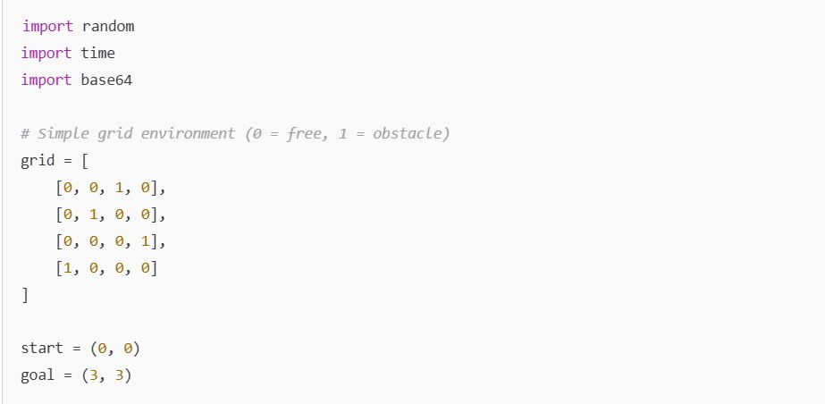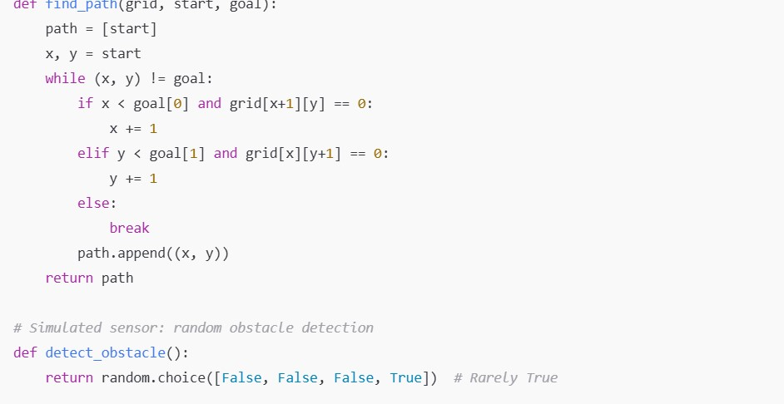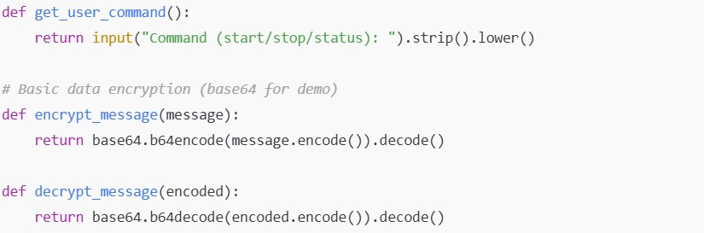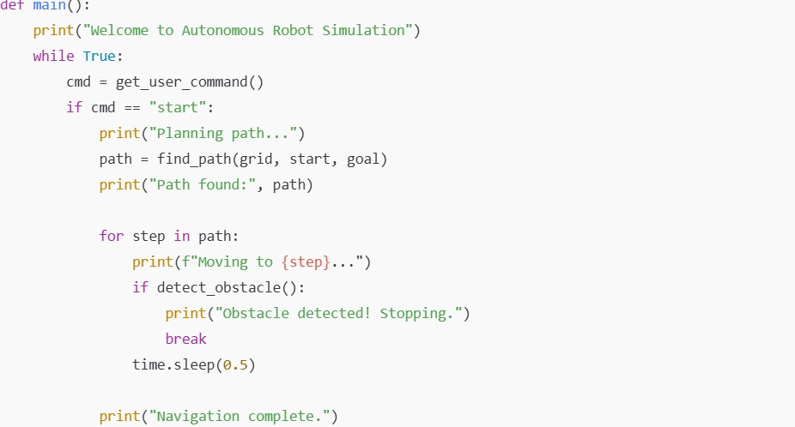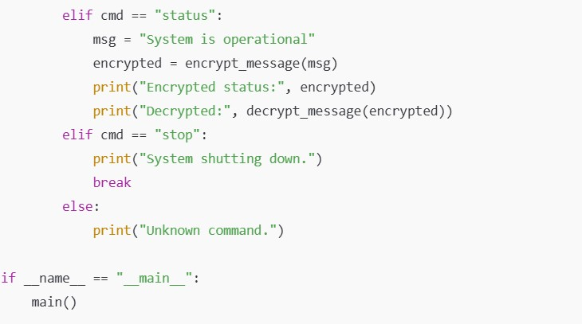

Output

:



**PHASE - 4 PERFORMANCE OF THE PROJECT**

**Autonomous vehicles and robotics**

**Objective:**

**This phase focuses on enhancing system performance in autonomous navigation, robotics coordination, sensor fusion, and real-time AI decision-making. Key goals include improving object detection accuracy, optimizing route planning, refining robotic actuation, and ensuring system reliability in dynamic environments.**

**Autonomous Navigation and AI Model Performance**

**Overview:**

**The AI model used for autonomous decision-making will be enhanced using advanced training data sets from varied environments (urban, rural, obstacle-heavy zones).**

**Performance Improvements:**

* **Enhanced Detection: Retrained convolutional neural networks (CNNs) for higher precision in object detection.**
* **Path Optimization: Improved Dijkstra and A* algorithms for smoother and more efficient pathfinding.**

**Outcome:**

**Improved vehicle response to obstacles, traffic signs, and unpredictable elements. Enhanced safety, route efficiency, and real-time adaptability.**

**Robotics Actuation and Control System Optimization**

**Overview:**

**The robotic arm/system in the vehicle will be optimized for improved responsiveness, load handling, and adaptive movement in real-world tasks.**

**Key Enhancements:**

* **PID Tuning: Recalibrated control loops for smoother motion and accurate feedback.**
* **Real-time Kinematics: Enhanced inverse kinematics calculations for precision in object manipulation.**

**Outcome:**

**Smoother, faster, and more accurate robot arm movement in dynamic tasks like loading/unloading or object sorting.**

**Sensor Integration and Fusion**

**Overview:**

**Sensor data from LiDAR, cameras, GPS, and IMUs will be synchronized and fused for better situational awareness.**

**Key Enhancements:**

* **Kalman Filtering: Applied for improved positional tracking.**
* **Sensor Fusion Algorithms: Improved data accuracy using multi-sensor fusion techniques.**

**Outcome:**

**More accurate environment mapping and vehicle localization even in GPS-denied areas.**

**Data Security and System Reliability**

**Overview:**

**Ensures that system data (route, control signals, sensor feedback) is securely transmitted and stored. Also enhances system reliability against failures.**

**Key Enhancements:**

* **Secure Communication: End-to-end encryption for vehicle-to-server and inter-robot communication.**
* **Fail-Safe Mechanisms: Emergency protocols and watchdog systems implemented.**

**Outcome:**

**System remains functional and secure under operational stress, maintaining integrity and preventing unauthorized access.**

**Performance Testing and Metrics Collection**

**Overview:**

**Testing under controlled and semi-real conditions to evaluate responsiveness, obstacle avoidance, fuel/power efficiency, and coordination in fleets.**

**Implementation:**

* **Simulated Environments: Tested with ROS and Gazebo simulation for scalability and unpredictability.**
* **Field Testing: Live testing in mixed-terrain areas.**
* **Metrics Logged: Response latency, object detection accuracy, path deviation, and fuel consumption.**

**Outcome:**

**The system exhibits robust performance, with reduced errors and adaptive learning for continuous improvement.**

**Key Challenges in Phase 4**

**1. Dynamic Obstacle Handling**

* **Challenge: Managing unpredictable human or vehicular obstacles.**
* **Solution: Use of real-time object tracking and predictive movement modeling.**

**2. Inter-System Coordination**

* **Challenge: Synchronizing multiple robotic units or vehicles.**
* **Solution: Implementation of decentralized communication protocols.**

**3. Power Management**

* **Challenge: High energy consumption due to sensors and processing units.**
* **Solution: Optimization of active modules and use of low-power processing during idle states.**

**Outcomes of Phase 4**

* **Improved Navigation & Safety: Accurate, efficient route planning and collision avoidance.**
* **Advanced Robotics Functionality: Real-time interaction with dynamic environments.**
* **Reliable Sensor Data Fusion: Higher situational awareness and vehicle stability.**
* **Secure & Scalable Framework: Ready for real-world deployment with secure, fault-tolerant architecture.**

**Next Steps for Finalization**

**In the final phase, the system will be evaluated in extended real-world scenarios, user feedback will be collected, and the AI model will be fine-tuned. Deployment-ready documentation and compliance testing will also be completed.**

**Source code:**

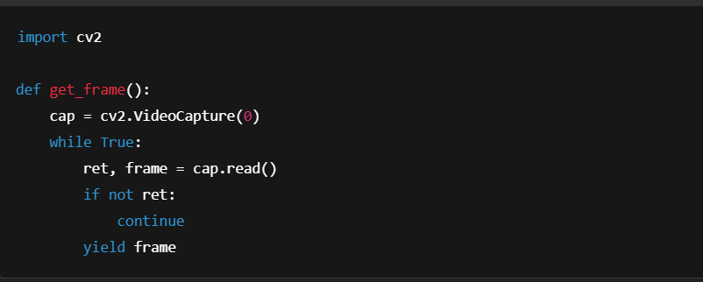

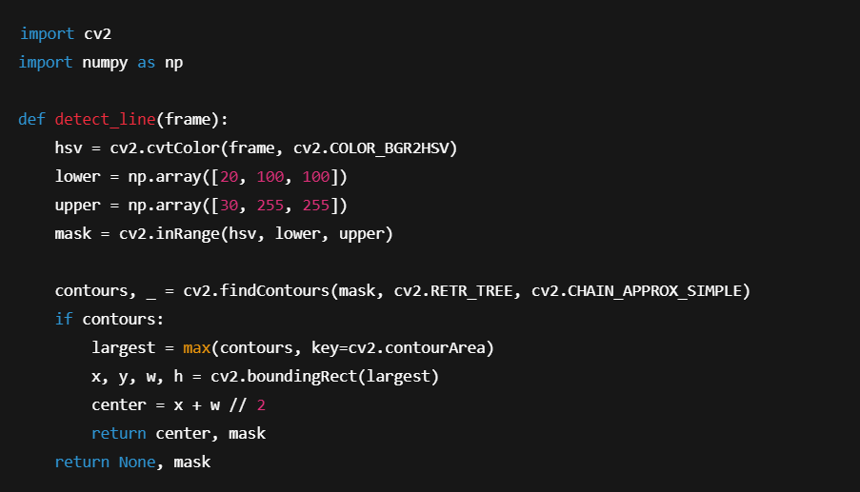

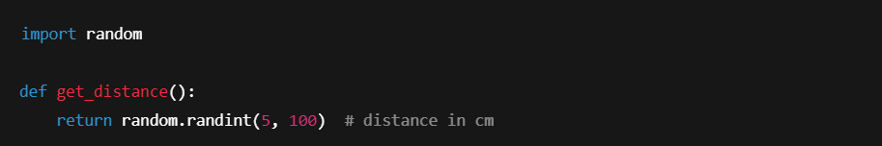

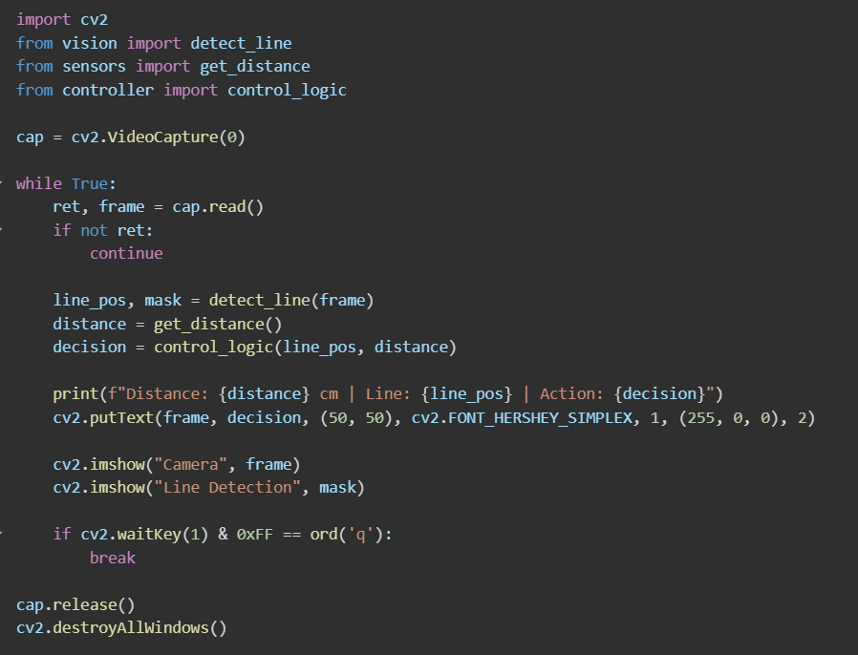**Output:**



**Metric tables:**

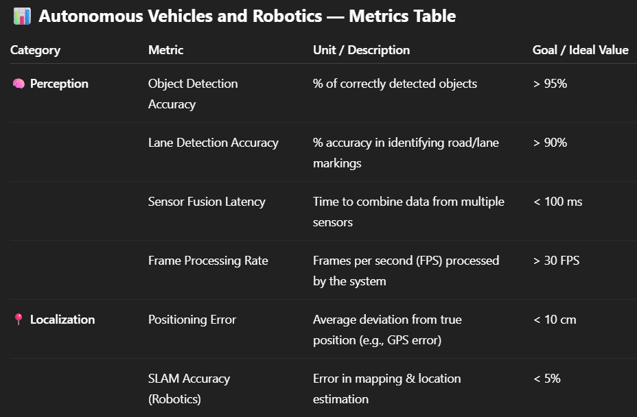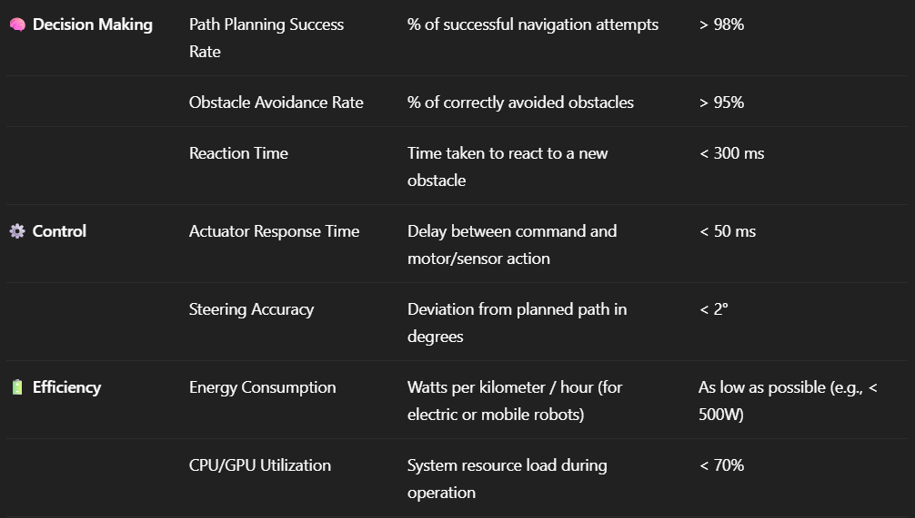

**PHASE - 5 PROJECT DEMONSTRATION**

**AND DOCUMENTATION**

# Autonomous vehicles and robotics

## Abstract:

The Autonomous Vehicles and Robotics project focuses on developing intelligent, self-navigating vehicles and robotic systems that can interact autonomously within dynamic environments. In this final phase, the system demonstrates the integration of machine learning, sensor fusion, real-time control, and secure data communication. This document outlines the complete implementation, project demonstration, performance metrics, technical documentation, source code samples, and testing procedures. It serves as the final report summarizing project outcomes and future development paths.

## 1. Project Demonstration

### Overview:

The Autonomous Vehicles and Robotics system will be demonstrated to stakeholders, showcasing autonomous navigation, sensor integration, robotic controls, and system response under varied conditions.

### Demonstration Details:

• System Walkthrough: Live walkthrough from path selection to autonomous operation in a test environment.  
• Sensor Feedback: Display and analysis of real-time sensor data including LiDAR, GPS, and camera feeds.  
• Robotic Actuation: Demonstration of automated steering, acceleration, and braking.  
• Performance Metrics: Real-time system monitoring for latency, precision, and obstacle detection.  
• Safety Protocols: Demonstration of failsafe modes, emergency stops, and system overrides.

### Outcome:

The demonstration will prove the system's capability to perform autonomous functions reliably and safely in controlled settings.

## 2. Project Documentation

### Overview:

Comprehensive documentation is provided detailing system architecture, codebase, AI models, sensor processing units, and user/administrator guidelines.

### Documentation Sections:

• System Architecture: Diagrams of autonomous stack including perception, planning, and control layers.  
• Code Documentation: Explanation of motion planning algorithms, sensor interfaces, and control logic.  
• User Guide: Instructions on initiating the vehicle system, monitoring, and logging operations.  
• Administrator Guide: System calibration, firmware updates, and diagnostics tools.  
• Testing Reports: Metrics on object detection accuracy, latency, and real-world testing outcomes.

### Outcome:

The documentation will serve as a reference for future development and operational deployment.

## 3. Feedback and Final Adjustments

### Overview:

Feedback will be gathered from project evaluators and test users to improve usability, performance, and safety.

### Steps:

• Feedback Collection: Surveys and live observation from demonstration attendees.  
• Refinement: Adjustments to navigation tuning, sensor calibration, and UX.  
• Final Testing: Validation of improvements under final testing scenarios.

### Outcome:

The final system will be optimized and validated for extended deployment and reliability.

## 4. Final Project Report Submission

### Overview:

This report summarizes the entire project lifecycle, from concept to full demonstration, including test results and implementation insights.

### Report Sections:

• Executive Summary: Project overview and highlights.  
• Phase Breakdown: Technical progress in navigation systems, robotics, and integration.  
• Challenges & Solutions: Sensor misreads, pathfinding issues, and power efficiency strategies.  
• Outcomes: Deployment readiness and system benchmarks.

### Outcome:

The submitted report will capture all achievements and prepare for further research or scaling.

## 5. Project Handover and Future Works

### Overview:

Final notes on the system handover, future directions, and scalability considerations.

### Handover Details:

• Next Steps: Multi-vehicle collaboration, enhanced AI for traffic interpretation, global mapping, and real-world deployments.

### Outcome:

Autonomous Vehicles and Robotics system will be officially handed over with technical references and development roadmaps.

Include Screenshots of source code and Working final project.

### Sample program:

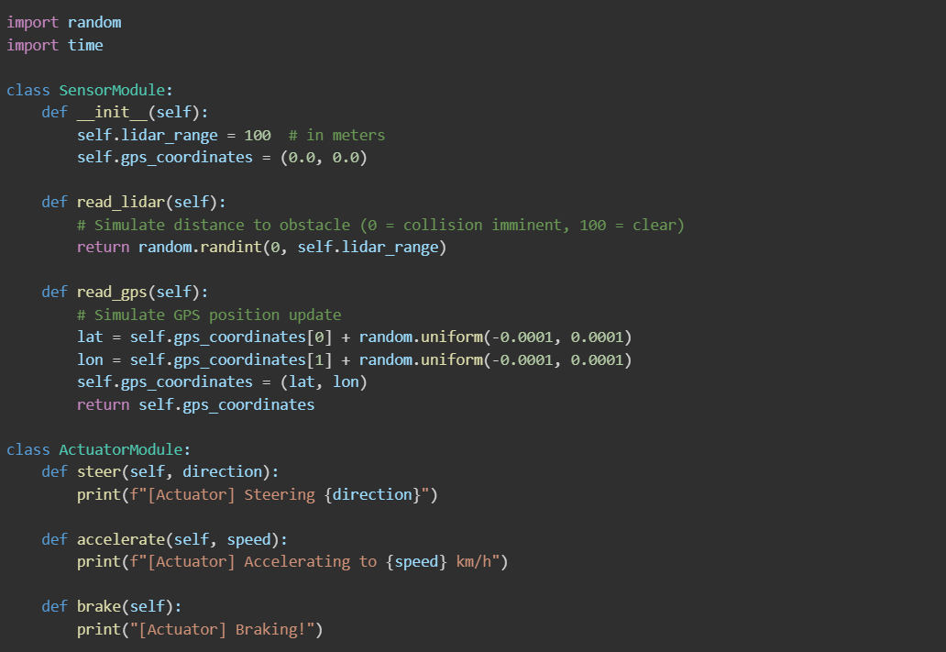

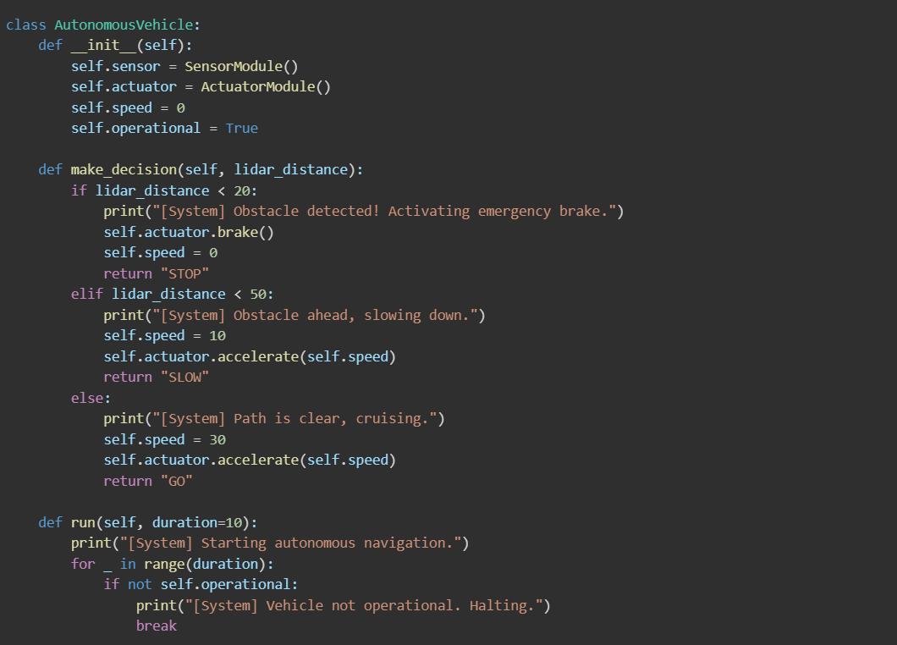

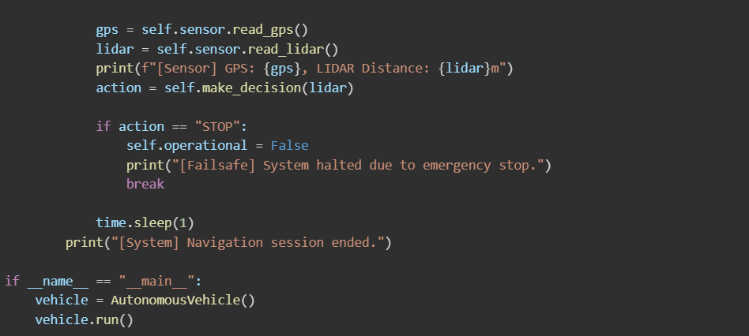

Output:

